**AIR UNIVERSITY**

**Name: Alwaz Siddique**

**Class: BsCs-B**

**Roll No: 233590**

**Submitting to: Abdul ghani sb**

**Passing by constant value**

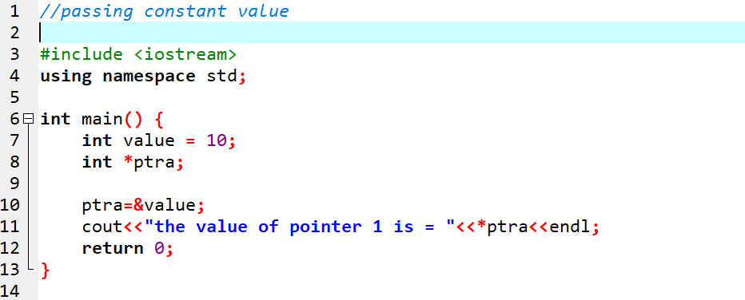

**As above we taking a constant vcalue and passing it to our pointer.**

**The output will be = 10.**

**Passing by user input**

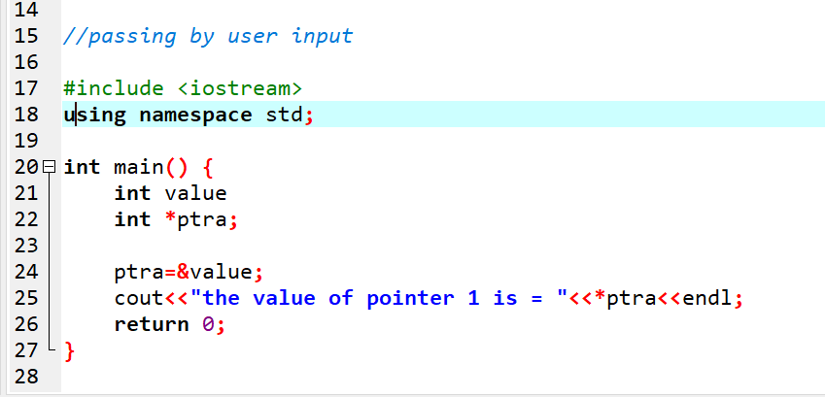

**As above we are taking user input and passing to our our pointer.**

**The out will be user given.**

**Passing by pointer to pointer**

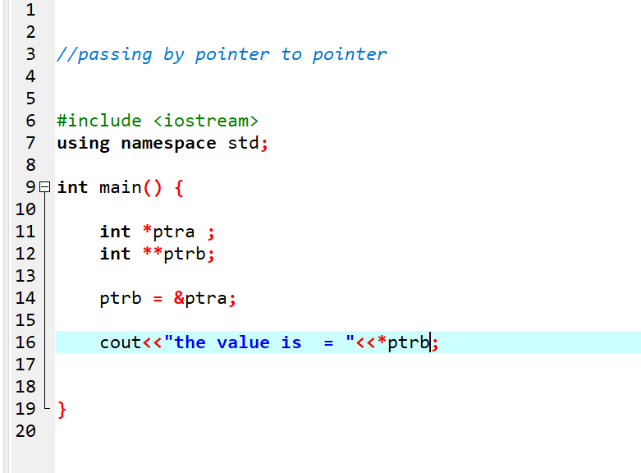

**As above the value will be 0 as we passing pointer to pointer.**